March 4th to 7th 2019
Crowne Plaza Hotel
Ventura, California

Presented by the Park Rangers Association of California
and the Park Law Enforcement Association
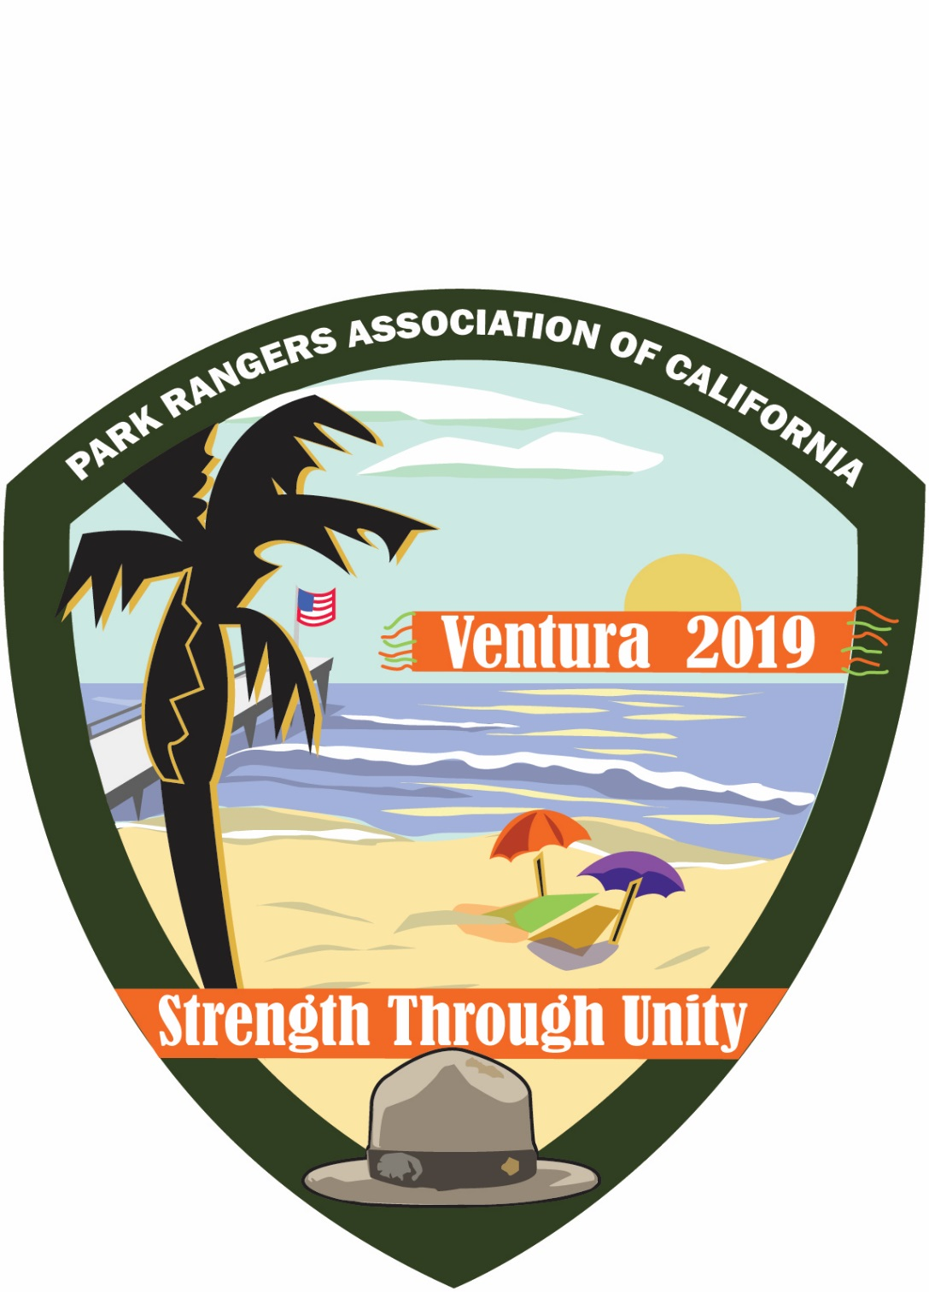
General Information

Conference Check-In
Welcome to Park Rangers Association of California (PRAC) and the Park Law Enforcement Association (PLEA) joint conference. Our associations’ leadership thanks you for attending this educational and entertaining professional conference. We are confident you will enjoy learning from, and networking, with, your law enforcement peers.

Check in will be in the hotel lobby and open from noon until 8:00 pm on Monday and 8:00 am to 5:00 pm on Tuesday and Wednesday. When you check in at the front desk, you will receive your information packet, meal tickets and any pre-ordered items. The front desk staff will be happy to answer any conference questions or help you find your classrooms

Conference Apparel
Conference T-shirts are available to purchase and will feature the 2019 colorful logo as a reminder of this year’s conference. Love the t-shirt, want another one or two? Extras are available for $20 each.

PRAC Accreditation
PRAC adopted minimum professional training standards for Park Rangers in 2001. The training standards provide a recommended minimum training level for a well-rounded generalist ranger. . Participants attending any of the training sessions that apply toward a PRAC learning domain will receive a certificate of completion to be used toward fulfilling PRAC’s standards. A roster will be provided in each room of qualifying sessions. Those wishing PRAC credit for a session must be sure to sign the PRAC roster.

Raffle
We are pleased to offer an array of eclectic items for this year’s raffle. The raffle will take place during the Wednesday evening banquet. Raffle items include Steiner Binoculars, Wood thin Green line American Flag Sign and more items!
Vendors
For the last 40 years, Flowbird has been in the business of supplying parking and transit systems around the globe. Our core expertise is in the areas of payment solutions – multi-space parking meters, mobile phone payment, ticket vending machines, fare collection devices and fare validation. Whether driving or taking public transportation, people around the world come into contact with Flowbird solutions every day. As cities become more congested and systems become more complex, Flowbird’s focus is to utilize our expertise to make travel easier within communities.

Monday, March 4
Field Trip
Hosted by the Ventura County Sheriffs’ Department
11:00 am to 2 pm
Camarillo Airport

We will meet at the Camarillo Airport, 375 Durley, Ventura County Sheriff- Hangar #3, RSVP Required.
The following sessions will be offered:
11:00-12:00 Helo operations- Hands on demo
Survival sea and land operations
Case Study
12:00-12:45 Lunch (free) included in registration
12:45-13:45 (Half the group will attend then rotate)
Working with K-9, demo
K-9 operations for enforcement, demo
12:45-13:45 (Half the group will attend and then rotate)
Hands on simulator for the following scenarios:
*Armed and unarmed subjects
*Pepper spray usage
*Taser usage

Welcome Reception
Meet from 6:00 pm to 9:00 pm in the Patio area outside, adjacent to the bar. Join fellow attendees for hors d’oeuvres, beverages and a chance to catch up with old and new friends. This will be a great way to kick off your attendance at the Conference! Free with full registration.

Tuesday, March 5th

Welcome and Keynote
8:00 am to 10:00 am

Welcome Address

Matt Cerkel, PRAC President and Bill Westerfield, PLEA President

Please wear your Park Ranger uniform for a group photo following the keynote speech.

Keynote Speaker

Professor Kerry Plemmons, University of Denver, Public Safety Leadership Program

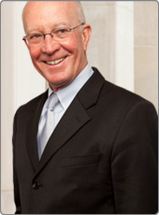
Kerry Plemmons
Professor of Practice
University of Denver, Daniels College of Business
2101 South University, #335 J, Denver CO 80208
Kerry.Plemmons@du.edu 720-280-7174

Kerry Plemmons has 30 years of entrepreneurial experience with success in launching and running small and medium-sized businesses in the U.S. and Mexico, and another 15 years as an academic and consultant. As an executive with Starbucks, Plemmons opened stores in the western U.S. and Canada, ran several test-market innovations, and led operations for a couple hundred stores. Prior to Starbucks, he partnered in creating the Pour la France!, restaurant chain in three states and Mexico. Since joining the University of Denver, Daniels College of Business full time in 2004, Plemmons has consulted to and built strategic plans with senior executives at Crocs, Kaiser Permanente, The American Camping Association, Colorado Parks and Wildlife, the Arapahoe County Board of Commissioners and Sheriff, Colorado Outdoor Education Center, the American Animal Hospital Association, Colorado Historical Foundation, Veterinary Management Group, Molson Coors, Environmental Chemical Corporation (ECC), Microsoft, DMB Development Company, Janus Capital Group, Monte Vista Cooperative, Anadarko Oil, DCP Midstream, Encano Oil, Intrado, First Data Corporation, Western Union and more.

During his15 years of teaching at the Daniels College of Business, University of Denver, Plemmons created and delivered new courses in a variety of subjects. His passion is connecting innovation to leadership through experiential educational processes. He also has passion for helping leaders in the public safety professions and leads the University of Denver Public Safety Leadership program. With a group of colleagues, Plemmons built a program called the Compass where all graduate business students experienced leadership, ethics, and sustainability first in the classroom and then in the mountains of Colorado. In the Executive MBA program, he teaches strategic marketing, innovation and a global business sequence that culminates in a two-week international experience to places like Israel, Singapore, Rwanda, South Africa, Botswana, South Korea, China, Vietnam, Brazil, Chile, Argentina, Russia, Mongolia, and Turkey.
Plemmons wrote, Juxtapositions: Comparing Mild to Wild Success – Irreverently. Juxtapositions looks at whole organizational success, where a kind and gentle revolution might create a strong cultural focus, when imagination leads to strategies that are implemented because they align with the organizational mission, and the individuals are rewarded and recognized so the imaginative strategy process gets repeated.
Most of Plemmons’ consulting consists of working with groups of 10 to 400 after finding gaps in the client organizations. Plemmons and a group of Daniels colleagues create a solution then build workshops and offsite sessions to close the gaps. In an average year, Plemmons works with 300 or more graduate students, and speaks to several thousand clients.

Public Safety Leadership
Creating Unity through Collaborative Cultures
Step One: Leading a Culture of Purpose and Resiliency
- What is the purpose behind your organization? How do we leverage the purpose/mission of your organization to build resiliency in the daily work?
- Creating Servant Leaders in every part of your organization.
- Understanding the broader culture and history of rangers, park police, park public safety, conservation.
Step Two: Collaborative Creativity for Great Implementation of Your Mission
- How does the purpose of your organization turn imagination into real strategies?
- Tools and techniques to build effective collaboration for excellent implementation.
Step Three: Aligning the Organization to Keep Good People and Attract Top Talent
- Are the core values, guiding principles and mission of the organization aligned with those who implement the strategies of the organization?
- How are good behaviors recognized and rewarded so they get repeated?
- How are bad behaviors recognized and tagged so that they are NOT repeated?

Step Four: Creating Unity throughout the Parks and Public Safety Community
- Sharing and cascading the mission, vision and values with the whole team
- Leading UP to build power behind the mission
- Collaborating with other agencies and stakeholders to celebrate the mission
- Pulling in the same direction to create a more stable future for rangers everywhere
- Influencing through Positive Peer Pressure

General Sessions
Park Operations and Resource Management Track

Surviving Storm Season
Tuesday March 5th 10:15 to 11:15
Session Description:
Discover how you can calm the storm season madness by planning and preparing for the worse. You’ll learn some top tips for getting through storm season relatively unscathed including real-life examples from the 2017 Canyon Fire 2.
Presenters:
Sue Stoffel, Maintenance Inspector Specialist, OC Parks
Jennifer Naegele, Natural Resources Manager, OC Parks
Kelly Brugmann, Resource Specialist, OC Parks

The Impacts of Encampments on Park Operations:
Tuesday March 5th 11:30 to 12:30
Session Description:

From natural resource management to routine maintenance services, we will discuss the impacts of encampments and how they have changed our policies, practices and procedures in park operations.
Presenters:
Kyla Brown, Assistance Director, RivCo Parks
Robert Williams, Natural Resources Manager, RivCo Parks
Sue Stoffel, Maintenance Inspector Specialist, OC Parks

Lunch: 12:30 pm to 2:00 pm

Tips and Techniques to Building Sustainable Trails:
Tuesday March 5th 2:15 to 3:15
Session Description:

Join us for a discussion on the basics of trails maintenance management including standards, materials, inspection and resources. Discover how you can create an annual work plan to maintain your trails for future stewards.
Presenters:
James Wootten, Supervising Maintenance Inspector Specialist, OC Parks
Sue Stoffel, Maintenance Inspector Specialist, OC Parks

Mountain Lions of the Santa Monica Mountains
Tuesday March 5th 3:30 to 4:30
Session Description:
Los Angeles is one of only two megacities in the world (the other is Mumbai) that have big cats living within the city limits. In a place more often associated with freeways and traffic, the fact that the city can support such large-ranging animals is a testament to the quality of open space and the habitat connectivity that still remains.
The National Park Service has been studying how mountain lions survive in an increasingly fragmented and urbanized landscape since 2002. Researchers have monitored more than 50 mountain lions in and around the Santa Monica Mountains. GPS collars provide detailed information about the animals' ecology and behavior.

Presenters:
Seth Riley, PHD
Jeff Sikich, NPS

Seth Riley grew up in Washington, D C where he first got interested in wildlife, by way of snakes. He graduated in 1988 from Stanford University with a B.A. in Human Biology, concentrating in Animal Behavior and Ecology. From 1988-1990 Seth worked as a wildlife biologist for the National Park Service at the Center for Urban Ecology in Washington. He worked on a number of urban wildlife issues there, focusing particularly on the behavioral, population, and disease ecology of urban raccoons. Seth then went to the University of California, Davis for graduate school, where he graduated with a Ph.D. in Ecology in 1999. His dissertation work was on the ecology of bobcats and gray foxes in urban and rural areas of Golden Gate National Recreation Area, just north of San Francisco. After graduating Seth worked as a post-doctoral fellow at Davis studying hybridization between native and introduced tiger salamanders in California. At the beginning of 2000, Seth began in his current position as Wildlife Ecologist with the National Park Service at Santa Monica Mountains National Recreation Area in southern California. His current projects, all related to the impacts of urbanization and fragmentation on wildlife, include a bobcat telemetry study, a mountain lion GPS telemetry study, stream surveys for amphibians, and pitfall/drift fence trapping to determine terrestrial reptile and amphibian distribution and abundance. Seth is also has an adjunct position at UCLA where he advises students and teaches graduate seminars. A recent project was co-editing a book on Urban Carnivores, for which Seth co-authored seven chapters.

Jeff Sikich is a graduate of Indiana University with a degree in Environmental Science and Management. Throughout his career Jeff has captured and handled over 16 carnivore species for wildlife research. His work specializes in safe capture and handling techniques for various large carnivores. He has worked on several projects in the United States researching a variety of species, as well as studies focused on tigers in Sumatra, jaguars and pumas in Central and South America, and leopards in South Africa. Jeff is currently a biologist with the National Park Service researching the impacts of urbanization and habitat fragmentation on mountain lions in the Santa Monica Mountain Range.

Wildlife Crossing 101
Tuesday March 5th 4:45-5:45
Session Description: Discuss importance of wildlife crossing and impacts for wildlife and humans.

Presenter: Beth Pratt-Bergstrom has worked in environmental leadership roles for over 25 years, and in two of the country’s largest national parks: Yosemite and Yellowstone. As Regional Executive Director of the California Regional Center of the National Wildlife Federation, “I have the best job in the world” she says. “While advocating for the state’s remarkable animals, I get to travel around California and spend time with condors, mountain lions, porpoises, pika, and foxes, and work with some amazing people who help wildlife thrive.”

Public Safety Track
Homeless Liaison-Legal Update in Park Environments
Tuesday, March 5th 10:15-11:15
Session Description:
Presenter: Juan Cordova-VCSO, Senior Dept. Head Homeless Unit

Drug Recognition-West Coast Trends
Tuesday, March 5th 11:30-12:30pm
Session Description:
Presenter: Captain Robert Thomas-VCO, Narcotics Manager

12:30-2pm Lunch
Hazmat Awareness
Tuesday, March 5th 2:15-3:15
Session Description:
Presenter: Chief John Spykerman-VCFD

Ventura Fire Overview/Lesson Learned
Tuesday, March 5th 3:30-4:30pm
Session Description:
Presenter: Kevin McGowan, Emergency Services Manager

Public Safety Leadership (PLEA)
Tuesday, March 5th All Day
Session Description:

Step One: Leading a Culture of Purpose and Resiliency
- What is the purpose behind your organization? How do we leverage the purpose/mission of your organization to build resiliency in the daily work?
- Creating Servant Leaders in every part of your organization.
- Understanding the broader culture and history of rangers, park police, park public safety and conservation.

Step Two: Collaborative Creativity for Great Implementation of Your Mission
- How does the purpose of your organization turn imagination into real strategies?
- Tools and techniques to build effective collaboration for excellent implementation.
Step Three: Aligning the Organization to Keep Good People and Attract Top Talent
- Are the core values, guiding principles and mission of the organization aligned with those who implement the strategies of the organization?
- How are good behaviors recognized and rewarded so they get repeated?
- How are bad behaviors recognized and tagged so that they are NOT repeated?

Step Four: Creating Unity throughout the Parks and Public Safety Community
- Sharing and cascading the mission, vision and values with the whole team
- Leading UP to build power behind the mission
- Collaborating with other agencies and stakeholders to celebrate the mission
- Pulling in the same direction to create a more stable future for rangers everywhere
- Influencing through Positive Peer Pressure

Presenter:
Kerry Plemmons
Professor of Practice
University of Denver, Daniels College of Business
Kerry.Plemmons@du.edu 720-280-7174

Park Interpretation Track

Bats
Tuesday, March 5th 10:15 to 11:15
Session Description:

There are many myths and misperceptions surrounding bats. This session will sort out fact from fiction. We will concentrate on bats found here in California, though there will be mention of those found elsewhere. We will also discuss some challenges bats are facing and things that can be done to help these wonderful little creatures.

Presenter: Dawn Soles is a Park Ranger with Livermore Area Recreation Parks District

Arachnids
Tuesday, March 5th 11:30 to 12:30
Session Description:

If you like to vote for the underdog and tend to like critters that makes most folks shudder and say eeewww!, then this is an opportunity for you. Spiders fascinate people almost as much as they freak them out. In this session we will look at spiders and their kin and a few tips and tricks to make them fun and not (as) freaky.

Presenter: Dawn Soles is a Park Ranger with Livermore Area Recreation Parks District

Critter Craniums and Crafts
Tuesday March 5th 2:15 to 3:15
Session Description:
Take a closer look at our critter craniums and how skulls have a significant connection with the Mexican celebration, Día de los Muertos. We will discuss a brief history of the celebration and how sugar skulls play a part in the festivities. Then, after examining various animal skulls, we will make our own critter cranium out of clay to decorate for the celebration.
Presenter: Kelley Bruggman
OC Parks’ Historic Resource Specialist, Kelley Brugmann, designs, implements and manages special events, interpretive programs and volunteer trainings for various historical parks in the county parks system. She also enjoys sharing her interpretive passion through various fun, interactive programs such as skulls, scat and starry nights.

Learning Styles for Roving Rangers
Tuesday, March 5th 3:30 to 5:00
Session Description:

People process information in a variety of ways such as reading, observing or listening. When you only have a few moments to connect with your audience, you need to provide information in a clear and concise manner. Hear how you can improve your communication skills for your park patrons by understanding learning styles.
Presenters:
Kelley Brugmann, Resource Specialist, OC Parks
Jennifer Naegele, Natural Resources Manager, OC Parks
Sue Stoffel, Maintenance Inspector Specialist, OC Parks

Drawing Native Plants and Animals
Tuesday, March 5th 4:45-5:45
Session Description:

Join Sama Wareh, author of "How to Draw 60 Native California Plants and Animals: A Field Guide" for a crash course in the finesse of field creativity. Learn the art of teachable moments, and how to create programs out of thin air, while enjoying tea from a native plant. Warning: You will be put on the spot in this fun and engaging workshop.

Presenter: Sama Wareh
Sama Wareh holds a M.S in Environmental Studies from California State University, Fullerton and a B.A. in Filmmaking and Art. A former director of outreach at the Environmental Nature Center, Sama developed 40 outreach programs. She currently teaches part-time at CSUF Fullerton in the Environmental Education Department and offers a variety of art and nature classes to different organizations. She has been a keynote speaker for conferences, addressed the United Nations on Education with a main focus on conservation, water issues, and seeing nature through art.
Sama is the author of "How to Draw 60 Native California Plants and Animals: A Field Guide" , gave a TED-x talk in 2014, and was awarded OC REGISTER's OCMETRO 40 under 40 award in 2013 for her humanitarian work.
www.warehart.com

Wednesday March 6th

General Sessions

Resource Management Track

Wednesday, March 6th 8:00-9:30
Session Description:
Discuss mission, volunteer program, training and funding for the Oakland trail program.

Presenter: Stan Dodson

Stan Dodson, manager of La Farine Bakery in Oakland’s Dimond District, and founder of the nonprofit organization Oakland Trails, has worked as a volunteer to promote, maintain, and enhance the trail system that connects Dimond Park to the Bay Area Ridge Trail since 2008. Stan provides leadership for community involvement up and down the hill, including producing the documentaries Trailhead (2015) and Old Survivor (2018), co-founding and managing Oakland Volunteer Park Patrol, offering free hiking tours, and leading ongoing trail maintenance and enhancement projects in Oakland’s wildland parks. Through these efforts, Stan strives to inspire outdoor recreation and park stewardship while shining a bright light on the City of Oakland.
Stan is a graduate of the Citizens Police Academy, has received three Local Hero awards from City of Oakland District 4 Councilmembers, and in 2014, La Farine was honored with a “Small Business of the Year” award from Oakland’s Mayor and City Council. In 2017, Stan received the Parkland Steward Award from Oakland Public Works, and the Anne Woodell Community Award, Oakland’s highest honor for community service in parks.
In 2018, Stan’s leadership was recognized with a San Francisco Bay Area Jefferson Award.

Marine & Wildlife Institute
Wednesday, March 6th 10:30 to 11:30
Session Description:

Presenter: Ruth Dover

Ebikes
Wednesday, March 6th 11:45 to 12:45
Session Description:
Presenter: John Munhall

Lunch and PRAC General Membership Meeting
12:45 pm to 2:00 pm

TBA
Wednesday, March 6th 2:15 to 3:15
Session Description:
Presenter:

Management and Rangers in San Pedro Mártir National Park
Wednesday, March 6th 3:30 to 4:30pm
Session Description:
Baja California peninsula is one of the most protected areas in Mexico, with about 70% of its territory being under a protection status such as Biosphere Reserves (BR), National Parks (NP) and Flora and Fauna Protection Areas (FFPA). San Pedro Mártir is a NP located in the central part of Baja California State, with mixed forest of conifer and chaparral ecosystems. Is an example of a Mexican Protected area designated only for conservation under the highest protection degree with different species introduction programs? Rangers watch out over 72,910 ha. Where permitted activities are delimitated by zones. In addition, they perform maintenance activities, environmental education, and fire control and management. Co-administrate by state and federal government, San Pedro Mártir is a particular case differing from other PA in Mexico, with state and federal guidelines regulating specific mechanisms, and in close collaboration with ONGs to reach goals described in its Conservation and Management Program. A description of this management model is presented.
Presenter: Gonzalo De Leon, Ph.D
Gonzalo has been director of “Sierra de San Pedro Mártir” National Park, in Baja California, Mexico for more than 8 years. He and his staff have focused on operating this federally protected area, one of the best-conserved conifer forests in Mexico, using different government programs, and building a network with academia professionals and researchers. He works to provide rangers and operation staff with the tools to do their jobs and to preserve San Pedro Martir considering the ecosystem service that provide to the region. As an ornithologist, his research area focus on monitoring golden eagles and promoting the condor introduction program in Baja California.
deleon.gonzalo@uabc.edu.mx

Public Safety Track

Initial Response to Missing Persons in a Park (SAR)
Wednesday, March 6th 8:00-9:00
Session Description:

Presenter: Captain Bill Schierman, Investigations, VCSO

Search and Rescue
Wednesday, March 6th 9:15-10:15
Session Description:

Presenter: Sergeant Don White, VCSO

Your Rights When Injured On The Job
Wednesday, March 6th 10:30-12:30pm
Session Description:

Presenters: Tom Wicke, esq; Lee Gold, esq; Justin Fieldman, esq

Crises Intervention in Parks
Wednesday, March 6th 2:15-3:15pm
Session Description:

Presenter: Mark Stadler, Crisis Intervention Coordinator, VCSO

Tactical Communications
Wednesday, March 6th 3:30-4:30pm
Session Description:

Presenter: Captain Mark Gillete, 911 Manager, VCSO

C.S.I In Park Environments
Wednesday, March 6th 4:45-5:45
Session Description:

Presenter: Sergeant Dean Worthy, Homicide Department, VCSO

Park Interpretation Track

TBA
Wednesday, March 6th 8:00-9:00
Session Description:
Presenter:

Interpretation Programming with Little or No Budget
Wednesday, March 6^{th,} 9:15-10:15
Session Description:
Interpretive programs are an invaluable resource that can be used to describe the myriad of reasons that our parks, beaches, trails, open space areas, etc., are to be loved, protected, and enjoyed responsibly, while providing a valuable education component.
While it’s commonplace for these programs to be widely available in parks that are managed by agencies with large budgets, the reality is that many park agencies which have suffered recession-era cutbacks in staff and budgets, cannot afford to provide effective interpretive programming. This presentation will provide examples how interpretive programming has been kept alive and well in Washoe County, Nevada, despite crippling budgetary setbacks.
Presenter:
Andy Brown is a park ranger with the Regional Parks and Open Space division of the Washoe County Community Services Department, in Reno, Nevada. He has also served as the Region 6 Director for PRAC since 2016.
Owls
Wednesday, March 6th 10:30-11:30
Session Description: Learn how to present a program about local owls using five senses.

Presenter Jenn Prewitt is an Orange County Parks Ranger and has been a classroom teacher with an interest in photography and traveling.

Photo 101
Wednesday, March 6th 11:15-12:15
Session Description: Learn a few simple tips and tricks to enhance everyday photos to the next level. We will discuss techniques like focusing, focal point, rule of thirds, point of view and using horizon lines.
Presenter Jenn Prewitt is an Orange County Park Ranger and has been a classroom teacher with an interest in photography and traveling.

“Stepping Stones of Engagement: a 4-step lesson design model to effectively teach any environmental/interpretation topic and highly impact your audience”
Wednesday, March 6th 2:15 to 3:15
Session Description:
Park rangers generally have a lot of knowledge of environmental issues and fun facts about the local flora and fauna to share, but do not necessarily have the educational background or training on how to develop and deliver an effective and engaging environmental education lesson or interpretation program about these topics.
This course will give rangers a solid foundational training on the most effective and up-to-date lesson development and delivery techniques that will not only help them understand and better connect with their audience, but also provide a memorable learning experience that truly leaves an impact. Lecturing is a teaching method of the past. As impressive as it may seem for park rangers in an interpretation talk to stand in front of their audience and “dump information” about a particular topic, most audiences cannot stay engaged with this teaching style and will most likely forget everything that was taught to them in this way.
“Stepping Stones of Engagement” is a course designed to help park rangers and staff think outside the box to improve their educational program design and teaching techniques using a clear and effective 4-step method that is easy to replicate in the field for any topic and any audience. Techniques shared include how to effectively build a relationship with and meet your audience, how to talk less when you are teaching and give your audience more of a chance to participate, talk, think, engage with each other, and ultimately how to create a memorable, thought-provoking, hands-on, or even empowering experience while your audience is learning.
Course attendees will get the opportunity to design a lesson themselves geared toward their park’s needs or expertise based on this 4-step model.

Presenter: Sarah Snell
Sarah received her B.A. from UC Santa Barbara and M.S. in Environmental Studies at the Universitat Autonoma of Barcelona in Spain, and has had diverse training in effective pedagogy for environmental education. She has been a planner for the U.S. Fish and Wildlife Service, an elementary and middle school teacher in expeditionary learning (EL) and bilingual public schools, led youth development programs in national parks in Washington DC and Yellowstone, and managed and trained others on coordinating engaging environmental education programs in Washington, DC. Sarah currently works for Washoe County Regional Parks & Open Spaces as a Park Ranger and is initiating educational programs this summer within her parks district.

TBA
Wednesday, March 6th 3:15-4:15
Session Description:
Presenter:

PLEA Sessions

Inter-agency cooperation
Wednesday March 6th 8:30-10:00
Session Description:

Presenter: Jewel Johnson

For the past 20 years, Jewel has worked as a Park Ranger for a Southern California local public agency in the Wildland-Urban Interface that is dedicated to the preservation and management of local open space and parkland, watershed lands, trails and wildlife habitat. As a Generalist Ranger, she is a California Peace Officer and Wildland Firefighter.

Building Success Memorandums of Understanding with Partner Agencies
Wednesday March 6th 10:30-12:00
Session Description:

Presenter: Lt. Mark Caughlin

Lt. Mark Caughlan is a District Manager for Larimer County Department of Natural Resources. Mark has worked 24 years as a park ranger with his department and currently manages the day to day operations for the third busiest reservoir in Colorado. While working on a degree in wildlife biology at Colorado State University he worked several seasonal wildlife related jobs including trapping and tagging black bears and fisheries management. Mark has gained a wide variety experience as ranger and public land manager. One of the largest areas of responsibilities of his job is developing and maintaining relationships with outside agencies and partners. Mark enjoys sharing the importance of building and maintaining external relationships to benefit public land agencies and their partners.

Engineering ocean conservation, how technology can support wildlife enforcement officers
Wednesday March 6th 1:30-2:30
Session Description:

Presenter: Sean Hastings

Sean serves as the Channel Islands National Marine Sanctuary's Resource Protection Coordinator. He is responsible for the development of policies and programs to address industrial, military, commercial and recreational uses and impacts in and around the Sanctuary. Sean has a Master of Marine Affairs Degree from the School of Marine Affairs, University of Washington, and a Bachelor of Arts in Environmental Studies, University of California at Santa Cruz.

Title: Utilizing Call Modality to Determine Staffing
Wednesday March 6th 2:30-4:30
Session Description:

Presenter: Hugo McPhee, Director of public Safety Three Rivers Park Police

Hugo McPhee is in his 28th year of law enforcement service and has been the Director of Public Safety at Three Rivers Park District (Minneapolis MN) since 2005. He has a master’s degree in management and has presented nationally on a variety of topics- most recently in 2017 at the US State Department Anti-Terrorism Conference in Washington D.C. Hugo has travelled to Mogadishu, Somalia to train and mentor senior leaders of their National Police as they strive to unite their country and bring stability to the country. He is presenting at Indiana University’s Great Lakes Training Institute and helped Miami-Dade County Parks establish a de-escalation best practices protocol in interacting with park visitors. Hugo also completed Harvard University’s Kennedy School of Government National Leadership Preparedness Institute where he collaborated on a project to streamline emergency medical response during hurricanes.

Thursday March 7th
Thursday's Training Field Trip
The Channel Islands National Park islands are only accessible by park concessionaire boats Island Packers, who we have chartered. Space is limited so please register early to help us with planning. We will board buses in the morning at our hotel for the short transfer to the Island Packer dock where we will board their boat for the trip through Channel Islands National Marine Sanctuary and into the Channel Islands National Park. The National Marine Sanctuary Protection Coordinator Sean Hastings will be with us to explain how law enforcement responsibilities are corradiated and conducted between the many agencies that protect the visitors and resources.
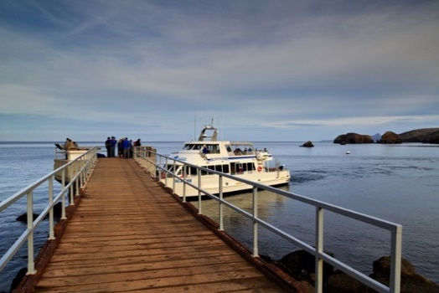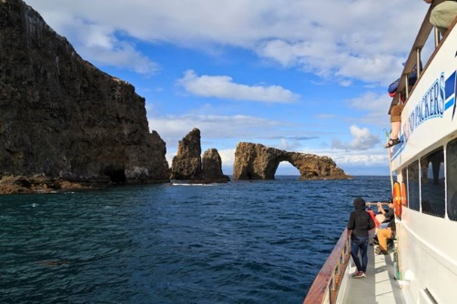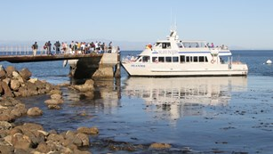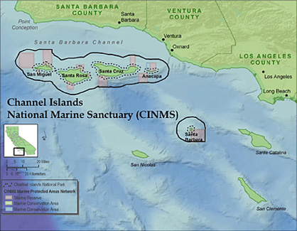
Sanctuary Overview
Channel Islands National Marine Sanctuary, located off the coast of Santa Barbara and Ventura counties in California, is one of 14 federally designated marine protected area administered by the National Oceanic and Atmospheric Administration (NOAA), within the Department of Commerce. The sanctuary encompasses 1,110 square nautical miles (1,470 square miles) of water from mean high tide to six nautical miles offshore of Santa Barbara, Anacapa, Santa Cruz, Santa Rosa, and San Miguel islands.
The sanctuary is a special place for species close to extinction, sensitive habitats, shipwrecks and maritime heritage artifacts. Many valuable commercial and recreational activities, such as fishing, shipping, and tourism occur in the sanctuary. A comprehensive ecosystem- based management approach is used to promote long term conservation of sanctuary waters, wildlife, habitats, and cultural resources, while allowing compatible human uses.
The sanctuary’s remote, isolated position at the confluence of two major ocean currents creates remarkable biodiversity. The mingling of cool, nutrient-rich waters from the north with warm currents from the south form a dynamic transition zone that is home to a myriad of sea life from microscopic plankton to blue whales.
Key management partners include but are not limited to:
Channel Islands National Park
NOAA Office of Law Enforcement, Southwest Division
NOAA Fisheries Service, West Coast Region
California Natural Resources Agency
California Department of Fish and Game
California State Lands Commission
The Nature Conservancy, Santa Cruz Island
U.S. Coast Guard
Sea Grant

Orange County Parks and partnerships
Wednesday March 6th 10:15-11:15
Session Description:

This session will focus on a brief history of OC Parks, types of properties managed, biggest challenges, what makes our agency different and how we work with other agencies to accomplish our mission.

Presenter: Candi Hubert started her career with OC Parks in 2007 and is currently the Senior Park Ranger for Whiting Ranch Wilderness Park. She has a bachelors from Sonoma State University in Environmental Studies with an emphasis in Natural Resources and Parks. She is currently the Vice President for the Park Rangers Association of California and the Region 5 Director. She has been the co-chair for 3 conferences in San Diego, La Quinta and now Ventura. She has attended the California Parks Training Conferences for the last 10 years.

Thursday's Training Field Trip
March 7th, 2019

The Channel Islands National Park islands are only accessible by park concessionaire boats Island Packers, who we have chartered. Space is limited so please register early to help us with planning. We will board buses in the morning at our hotel for the short transfer to the Island Packer dock where we will board their boat for the trip through Channel Islands National Marine Sanctuary and into the Channel Islands National Park. The National Marine Sanctuary Protection Coordinator Sean Hastings will be with us to explain how law enforcement responsibilities are coordinated and conducted between the many agencies that protect the visitors and resources.

Sanctuary Overview

Channel Islands National Marine Sanctuary, located off the coast of Santa Barbara and Ventura counties in California, is one of 14 federally designated marine protected area administered by the National Oceanic and Atmospheric Administration (NOAA), within the Department of Commerce. The sanctuary encompasses 1,110 square nautical miles (1,470 square miles) of water from mean high tide to six nautical miles offshore of Santa Barbara, Anacapa, Santa Cruz, Santa Rosa, and San Miguel islands.

The sanctuary is a special place for species close to extinction, sensitive habitats, shipwrecks and maritime heritage artifacts. Many valuable commercial and recreational activities, such as fishing, shipping, and tourism occur in the sanctuary. A comprehensive ecosystem- based management approach is used to promote long term conservation of sanctuary waters, wildlife, habitats, and cultural resources, while allowing compatible human uses.

The sanctuary’s remote, isolated position at the confluence of two major ocean currents creates remarkable biodiversity. The mingling of cool, nutrient-rich waters from the north with warm currents from the south form a dynamic transition zone that is home to a myriad of sea life from microscopic plankton to blue whales.

Closing Awards Banquet: included with full registration
Wednesday, March 6th 6:30 to 9:30 pm

Please join us for a lovely meal, a chance to visit with old friends and new friends at our annual awards banquet as we close our 43 years serving California and Nevada’s uniformed park professionals. We will also be awarding our 2019 Honorary Lifetime Member award during the banquet. This year we will have awards for both PLEA and PRAC at this banquet.

