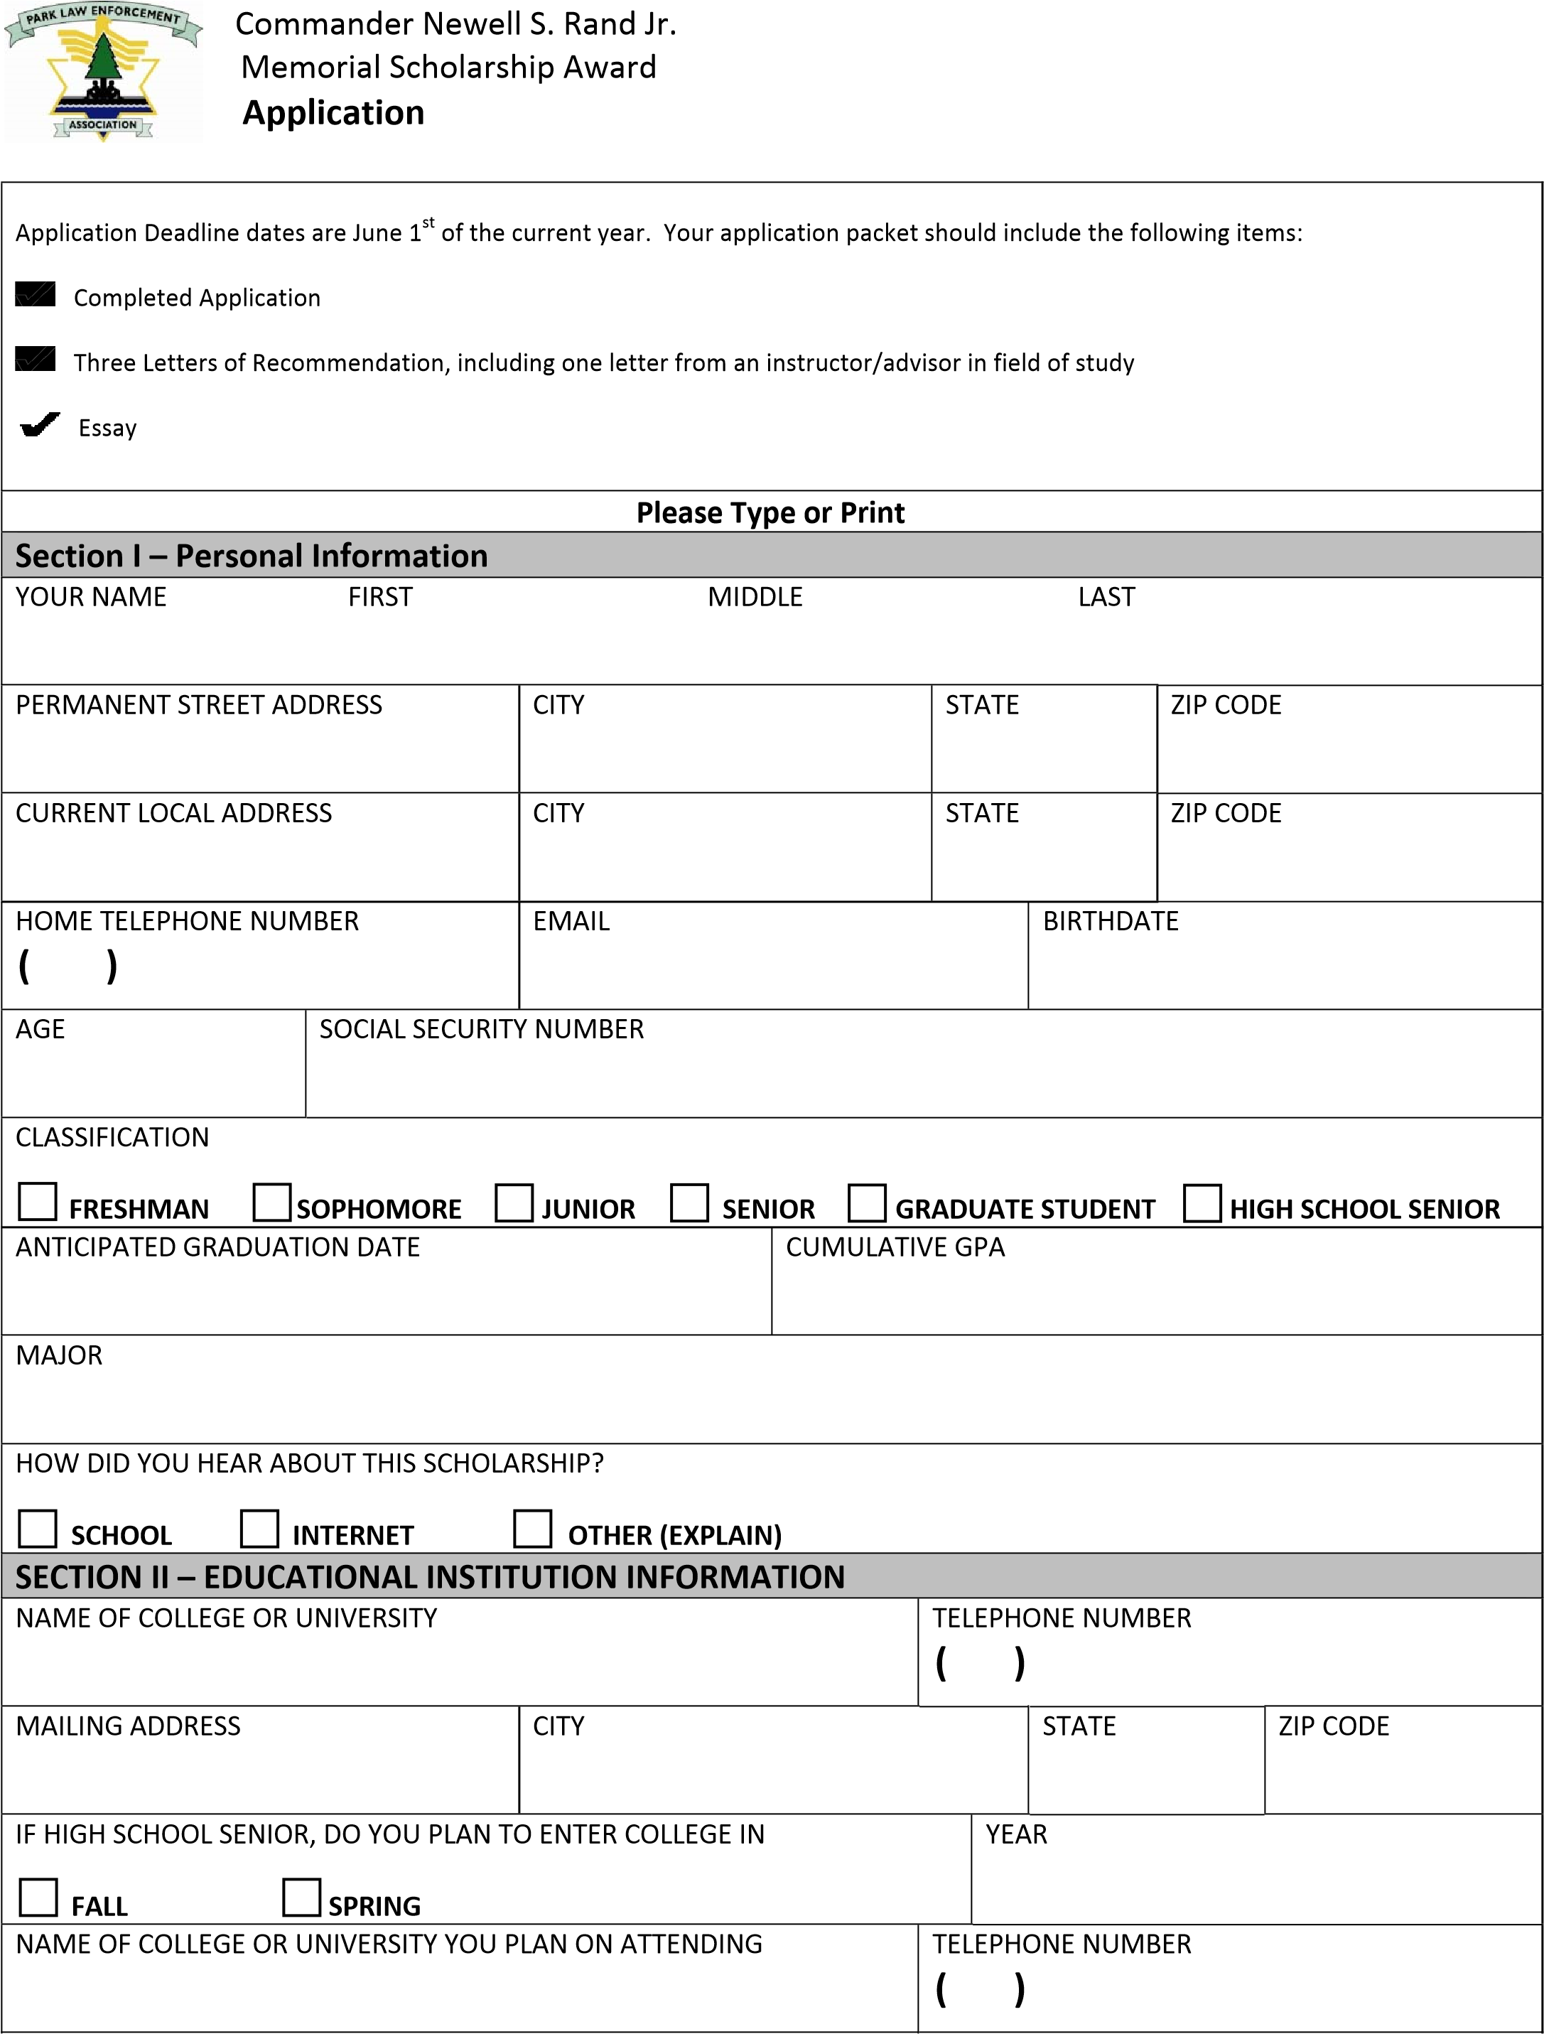
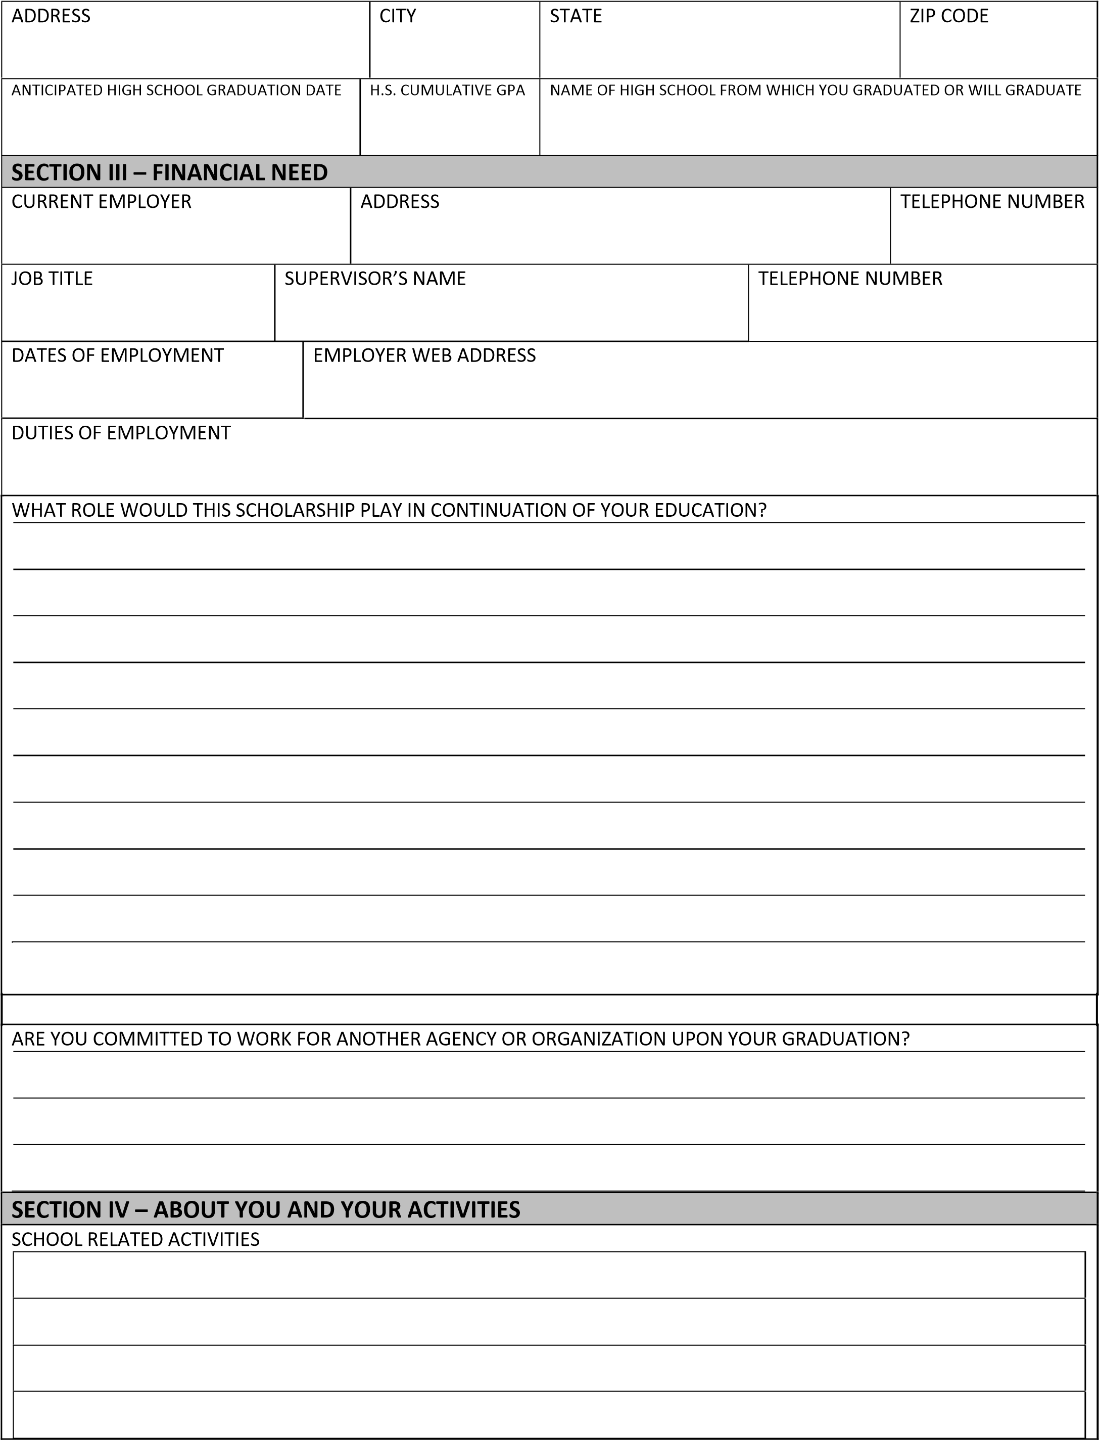
HONORS OR AWARDS
 | COMMUNITY, VOLUNTEER, CHURCH, YOUTH GROUPS, TALENTS OR SPECIAL INTERESTS
WHAT IS THE HIGHEST LEVEL OF EDUCATION YOU ENVISION ATTAINING AND IN WHAT DISCIPLINE?
WHAT ARE YOUR PRIMARY CAREER GOALS?
SECTION V ‐ ESSAY
ON A SEPARATE SHEET PROVIDE A BRIEF (250 WORDS OR LESS) DESCRIPTION OR STATEMENT REGARDING YOUR PARK LAW ENFORCEMENT EDUCATION CAREER GOALS.
I hereby certify that the information contained in this application is true and correct to the best of my knowledge. I authorize the release of any information pertaining to my grades or academic standing and the extent of my financial need to any Park Law Enforcement Association (PLEA) representative who request this information.
APPLICANT’S SIGNATURE |  | DATE
PLEASE COMPLETE AND RETURN THIS APPLICATION TO:
Park Law Enforcement Association
4397 McCullough St.
Port Charlotte, FL 33948
executivedirector@parkranger.org

